Capsulefy: Reviewer’s guide

**Relevant information:**

* Landing page: [https://capsulefy01.herokuapp.com](https://capsulefy01.herokuapp.com/)
* Sprint deployment: [https://capsulefy03.herokuapp.com](https://capsulefy03.herokuapp.com/)
* Sprint release: <https://github.com/pabreblob/capsulefy/releases> (Release 3)
* GitHub project: <https://github.com/pabreblob/capsulefy>

Capsulefy is an online time capsule that allows users to store their memories and share them in the future. Users will be able to create a time capsule, attach a message to it, load files such as videos or images into it and set a date when they want the capsule to be released. Users can connect their capsules with social networks and set a dead-man switch on the capsules, which works as a timer. If a user has not refreshed his capsule timer and it reaches 0, the capsule will be automatically released regardless of its publication date.

**Evaluators will receive multiple users credentials in a README file that will not be included in our repository for privacy reasons.**

When not logged in, a user is only able to list capsules that have been released, search a specific capsule using a keyword contained in the title, release date or description.

By clicking on “Search capsules” a list with all the capsules available will appear, as well as a search bar

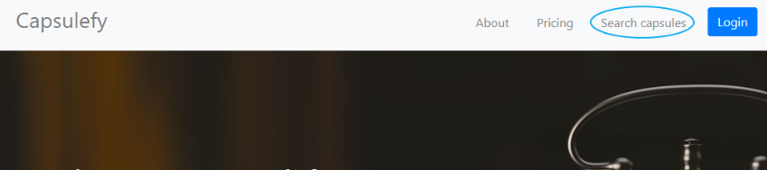

By clicking on “Display capsule” the contents of the capsule will be fully displayed.

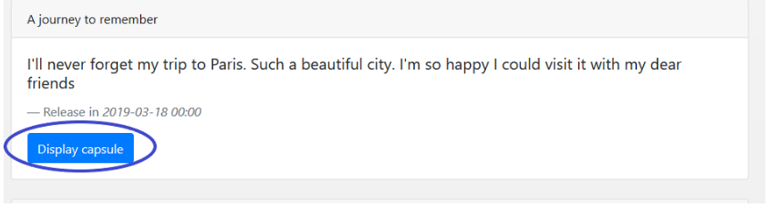

By clicking “Sign up”, the sign up form to register a new user will appear.

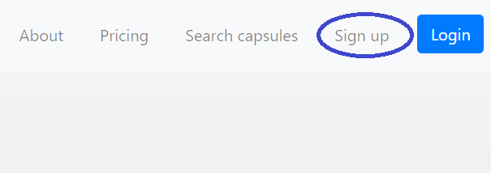

A user who is logged in can go to his profile and connect their twitter account with our application, change the email address that will receive a notification when a dead-man switch is about to expire´, and delete his user account and all his capsules.

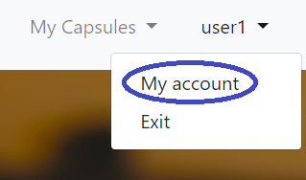

When logged in, each user can create free capsules, with the restriction of only being able to store inside them up to 20mb in total per user.

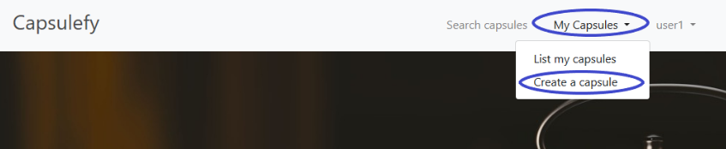

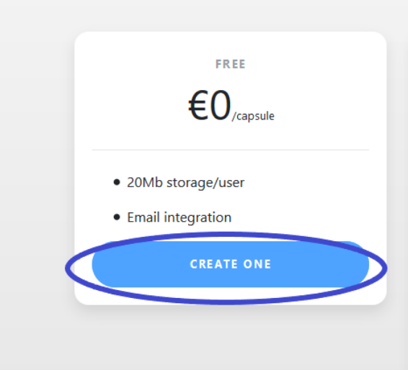

In order to create the capsule, it is necessary to introduce at least a title, a description and a publication date following the pattern dd/mm/yyyy, being yyyy the year, mm the month and dd the day. By clicking on the arrow at the right of that input field, a calendar will appear in order to make easier the date selection. In the email fields, multiple emails can be entered, separated by “,”, and an email will be sent to them when the capsule is released. Finally, files can be uploaded, as long as they don’t exceed the free user limit. Capsules published by the user logged in can be listed by clicking “my capsules”. These capsules can be edited as long as they have not been released and they can be deleted anytime. To edit or delete a capsule, please go to “List my capsules”, display the capsule to modify or delete and click the “Edit” or “Delete” button.

When clicking on “Create a capsule”, users can also choose to create a premium capsule instead of a free one by paying 11.99€, although for this prototype payment is not implemented, so creating a modular capsule is as simple as following the previous process. However, it has some additional fields. Firstly, a premium capsule can be made private. By selecting this checkbox, the capsule with not be included in our listings and user can only access to it if they know its url. There is also the option of setting a dead-man switch. By clicking the checkbox of “Create dead-man switch”, a new option will appear in the form, with allows to customize the time after which the capsule will be automatically published if the user has not refreshed it. At the moment, our timers are updated once a day, at 00:00h. It should be taken into account that the check in order send capsule publication mails or post a message on Twitter is also done at 00:00h every day.

Lastly, these premium capsules are divided into modules. If the user wishes to, he can click on “add module” to create a new module inside the capsule, with a different description, release date and files. These modules can be deleted and modified.

**After sending the form with the premium capsule data, the user will be redirected to Paypal in order to make the payment.** We are using a sandbox gateway, and in our README file we will include some credentials in order to make the payment. After the payment is done, the capsule will be created and ready to be published when the time comes.

In order to refresh the timer of a capsule, it is necessary to display it and press the “refresh” button.

Administrators can list the users in the system and ban/unban them

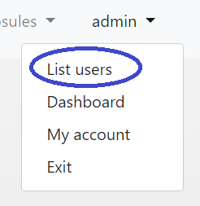

They can also display a dashboard with some information about the capsules and users created.

